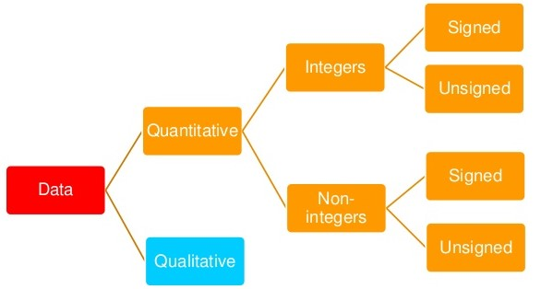

* Data Representation Computers can sense when an electrical signal being sent is either on or off. This is represented by a '1' (on) or a '0' (off). Each individual 1 or 0 is called a binary digit or bit and it is the smallest piece of data that a computer system can

Work with.

* One byte provides enough codes (256) to represent all of the characters that appear on a standard keyboard. A byte is the basic unit used to measure computer memory size.

|  |  |
| --- | --- |
| Bit | 1 or 0 |
| Byte | 8 Bits |
| Kilobyte (Kb) | 1024 bytes |
| Megabyte (Mb) | 1024 kilobytes |
| Gigabyte (Gb) | 1024 megabytes |
| Terabyte (Tb) | 1024 gigabytes |
|  |  |

* We can represent any number, however large, in binary. Remember we can only store numbers between 0 and 255 in one byte. This is obviously rather restrictive since it's not dealing with large integers, negative numbers or decimal numbers.

|  |  |  |  |  |  |  |  |  |
| --- | --- | --- | --- | --- | --- | --- | --- | --- |
| **27** | **26** | **25** | **24** | **23** | **22** | **21** | **20** | first eight binary powers |
| **128** | **64** | **32** | **16** | **8** | **4** | **2** | **1** |  |
| 0 | 1 | 0 | 0 | 0 | 0 | 1 | 1 | =67 |
| 1 | 1 | 1 | 1 | 1 | 1 | 1 | 1 | =255: the largest number represented in just one byte |
| 0 | 0 | 0 | 0 | 1 | 1 | 0 | 0 | =12 |